**SUMMER INTERNSHIP REPORT**

**[Web Developement]**

***Submitted in Partial Fulfilment of the Requirements for the Award of the Degree of******Bachelor of Technology in [CSE]***

Submitted By  
**[Lekhnath Parajuli]**  
Registration No:   
[1212122]

Under the Guidance of

**[Lekhnath Parajuli]**



**Session: 2025, jun**

**GOVERNMENT POLYTECHNIC JEHANABAD ,**

Affiliated to

**Bihar Engineering University**  
**Internship Duration: [1 jun] to [28 jun]**

**INTERNSHIP CERTIFICATE**

**(From Organization)**

*(Attach the Internship Completion Certificate issued by the company/organization where you interned.)*

**Name of Department**

**GOVERNMENT POLYTECHNIC JEHANABAD ,**



**CERTIFICATE**

This is to certify that **[Student name]**, Roll No. **[Your Roll Number]**, a student of **[Your Department]**, [College Name], has successfully completed the summer internship at **[Company/Organization Name]**, from **[Start Date] to [End Date]** as part of the AICTE internship program.

The student has submitted a report based on the work undertaken during this internship, which is in accordance with AICTE guidelines.

Signature of Student Signature of Faculty Mentor  
 **(Name & Designation)**

**ACKNOWLEDGEMENT**

Express gratitude towards the organization, mentor, faculty, and anyone who guided you during the internship.

Example:

I sincerely thank **[Organization Name]** for providing me with an opportunity to work as an intern. I extend my gratitude to **[Industry Mentor Name]** for their valuable guidance. I am also thankful to **[Faculty Mentor Name]** and my college for their continuous support and encouragement.

**DECLARATION**

I, **[Your Name]**, Roll No. **[Your Roll Number]**, hereby declare that this internship report is an original work carried out by me under the guidance of **[Faculty Mentor Name]** and **[Industry Mentor Name]**. It has not been submitted to any other university or institution for the award of any degree.

Signature of the Student  
Date:

**TABLE OF CONTENTS**

1. **Abstract**
2. **Introduction**
3. **Company Profile**
4. **Objectives**
5. **Tasks and Responsibilities**
6. **Technical & Managerial Skills Learned**
7. **Challenges Faced & Solutions**
8. **Conclusion & Recommendations**
9. **References**

**Abstract**

**This Web Development internship provides a comprehensive introduction to foundational programming concepts and essential web development functionalities. The program begins with an "Introduction to web development" and delves into core elements like “HTML Tags”, “CSS Styling”, “CSS Selectors”, “Flex”, “Grid”, "Variables," "Data types," and the underlying mechanics of "How JavaScript Works." Participants will gain practical experience with "Basic Operators" and perform "Basic Input & Output Operations."**

**The curriculum then progresses to control flow mechanisms, including "Break & Continue" statements, the", "if statements," "While loops," and "For loops," leveraging the "For of", “For in”, “Map”, “Filter”, “For Each” for iterative tasks. Data structures are explored through “objects", “list”, “String”, “Number” providing a solid understanding of organizing and manipulating data.**

**Introduction**

Web development is the art and science of creating websites and web applications that live on the internet. At its foundation, it’s built on three core technologies:

1. **HTML (HyperText Markup Language):**
2. This is the backbone of every webpage. It structures the content—headings, paragraphs, images, links, etc. Think of it as the skeleton of a site.
3. **CSS (Cascading Style Sheets):**

While HTML structures the content, CSS is what makes it beautiful. It handles layout, colors, fonts, and animations, giving websites their look and feel.

1. **JavaScript:**

This brings a website to life by adding interactivity. From form validation to image sliders and dynamic content updates—it’s JavaScript making that happen.

That sounds like a fantastic roadmap for diving into web development, Prince! Let’s break it down into digestible parts so you can build a strong foundation:

### **🌐 Introduction to Web Development**

Web development is the process of creating websites and web applications. It involves both **frontend** (what users see) and **backend** (server-side logic) development. Your focus here is on the frontend essentials.

### **🧱 HTML Tags**

HTML (HyperText Markup Language) uses **tags** to structure content. Common tags include:

* <h1> to <h6> for headings
* <p> for paragraphs
* <a> for links
* <img> for images
* <div> and <span> for layout and styling hooks

### **🎨 CSS Styling & Selectors**

CSS (Cascading Style Sheets) controls the look of your HTML. You’ll learn:

* **Styling**: Changing colors, fonts, spacing, etc.
* **Selectors**: Targeting elements using tag names (p), classes (.className), IDs (#idName), and more [like this guide explains](https://www.w3schools.com/CSS/css_selectors.asp).

### **📐 Flex & Grid**

These are powerful CSS layout systems:

* **Flexbox**: Great for one-dimensional layouts (rows or columns).
* **Grid**: Ideal for two-dimensional layouts (rows *and* columns).

### **🧮 JavaScript Essentials**

JavaScript adds interactivity. You’ll explore:

* **Variables**: let, const, and var to store data
* **Data Types**: Strings, numbers, booleans, arrays, objects
* **Basic Operators**: +, -, *, /, %, ==, ===, etc.
* **Input & Output**: Using prompt() for input and console.log() or alert() for output
* **How JS Works**: It runs in the browser, line by line, using an engine like V8 (in Chrome)
* element.addEventListener("click", function() { ... })

**Why is Web Development Important?**

* **Foundation for Advanced Topics:** Understanding the basics (like HTML, CSS, and JavaScript) is the first step to learning more advanced web technologies. Without these, it's hard to understand more complex tools or frameworks later on.
* **Problem-Solving Skills:** Learning the fundamentals helps you develop problem-solving skills. You'll learn how websites work and how to fix issues when things go wrong.
* **Readability and Maintainability:** Knowing the core concepts helps you write clean and organized code, which makes it easier to update or fix websites in the future.
* **Versatility:** Core web skills are used everywhere from simple websites to complex apps. Once you understand the basics, you can build a wide variety of projects.

Becoming a full stack developer is like being the Swiss Army knife of web development—you can do it all! But like any role, it comes with its perks and pitfalls. Here's a balanced look:

### **✅ Pros of Being a Full Stack Developer**

1. **Versatility & Independence**
2. You can handle both frontend and backend tasks, which means you can build entire applications on your own.
3. **High Demand & Job Opportunities**

Companies love hiring developers who can do it all—especially startups and small teams.

1. **Better Understanding of Projects**

You see the big picture, making it easier to troubleshoot, optimize, and collaborate across teams.

1. **Career Flexibility**

You can work as a freelancer, join a company, or even launch your own product.

1. **Continuous Learning**

You get to work with a wide range of technologies, which keeps things exciting and helps you stay current.

### **⚠️ Cons of Being a Full Stack Developer**

1. **Jack of All Trades, Master of None**

You might not go as deep in any one area, which can be a disadvantage for highly specialized roles.

1. **Overwhelming Workload**

Managing both frontend and backend can be mentally taxing, especially under tight deadlines.

1. **Constant Learning Curve**

Tech evolves fast. Staying updated on both ends of the stack can feel like a never-ending race.

1. **Perception Issues**

Some employers may question whether you have enough depth in either frontend or backend to handle complex tasks.

**Abbreviations**

There isn’t a widely accepted **abbreviation for "web developer"** itself—most people just say the full term. However, in casual or internal use, some might shorten it to:

* **Web Dev** – the most common shorthand
* **WD** – occasionally used in documentation or file names
* **Full Stack Dev** – if referring to someone who handles both frontend and backend

But more often, you'll see abbreviations for the **technologies** web developers use, like:

* **HTML** – HyperText Markup Language
* **CSS** – Cascading Style Sheets
* **JS** – JavaScript
* **API** – Application Programming Interface
* **DOM** – Document Object Model

"Web Dev" is your best bet.

**Objectives**

By the end of this internship, participants will be able to:

1. **HTml Basics:**
   * Learn how to create web pages using HTML tags (like <h1>, <p>, <div>, etc.).Setup vs code / online editor for to start developing
   * Understand how to structure a simple webpage with headings, paragraphs, images, links, and lists.
2. **CSS Basics:**
   * CSS Selectors: Learn how to select and style elements on your web page (like colors, fonts, and sizes).
   * Apply styles to different tags, classes, and IDs to customize the look of your website.
3. **JavaScript Basics:**
   * Write simple JavaScript code to add interactivity to your website, like showing alerts or changing content dynamically.

**JavaScript Fundamentals for Beginners**

1. **Variables:**
   * Declaring Variables: Learn how to create variables using let, const, and var. These are used to store values like numbers, text, and more.
   * Follow JavaScript rules for naming variables (no spaces, must start with a letter, etc.).
   * Understand where variables can be accessed whether inside a function or globally.
2. **Functions:**
   * Learn how to define functions using the function keyword. Functions allow you to group code that you can call later to perform a task.
   * Understand the concept of parameters (inputs to the function) and return values (outputs from the function).
3. **Loops:**
   * For Loops: Learn how to use for loops to repeat a block of code a set number of times.
   * While Loops: Use while loops to repeat code while a condition is true. Useful when you don’t know how many times the loop should run.
   * Break and continue: (break stops the loop completely, continue skips to the next iteration of the loop)
4. **Break & Continue:**
   * Control loop execution flow using break to exit loops prematurely.
5. **DOM Manipulation:**
   * Understand how to access and change elements in an HTML page using JavaScript, using methods like getElementById or querySelector.
   * Learn how to respond to user interactions like clicks, typing, or mouse movements by using event listeners.
6. **Promises & Callbacks::**
   * Callbacks: Functions passed as arguments to other functions. They help you run code after some task is completed (like fetching data from a server).

**COMPANY PROFILE**

* Name of the organization
* Location and contact details
* Overview of the industry
* Services/products offered
* Organizational structure (if applicable)

**TASKS AND RESPONSIBILITIES**

Here’s a clear and concise table outlining the **key tasks and responsibilities of a web developer**, Prince. This should give you a solid overview of what the role typically involves:

|  |  |
| --- | --- |
| **Category** | **Tasks & Responsibilities** |
| **Frontend Development** | - Design and build user interfaces using HTML, CSS, and JavaScript |
|  | - Ensure responsive design across devices |
|  | - Optimize UI for performance and accessibility |
| **Backend Development** | - Develop server-side logic and APIs |
|  | - Manage databases and data flow |
|  | - Ensure security and data protection |
| **Testing & Debugging** | - Test websites for functionality and fix bugs |
|  | - Perform cross-browser and cross-device testing |
| **Maintenance** | - Update content and features regularly |
|  | - Monitor site performance and uptime |
| **Collaboration** | - Work with designers, content creators, and project managers |
|  | - Translate client or team requirements into technical solutions |
| **Documentation** | - Write clean, maintainable code with comments |

### **🧩 Core Responsibilities of a Web Developer**

|  |  |
| --- | --- |
| **Category** | **Tasks & Responsibilities** |
| **Website Development** | - Write clean, efficient code using HTML, CSS, JavaScript, and backend languages |
|  | - Build responsive and accessible websites for all devices |
| **Frontend Engineering** | - Design intuitive user interfaces and implement UI/UX best practices |
|  | - Use frameworks like React, Vue, or Bootstrap for dynamic layouts |
| **Backend Engineering** | - Develop server-side logic, APIs, and database interactions |
|  | - Work with technologies like Node.js, PHP, Python, or Java |
| **Testing & Debugging** | - Perform cross-browser testing and fix compatibility issues |
|  | - Use tools like Chrome DevTools, Jest, or Postman for debugging |
| **Maintenance & Updates** | - Monitor site performance, uptime, and security |
|  | - Regularly update content, features, and plugins |
| **Collaboration** | - Work with designers, content creators, and project managers |
|  | - Participate in agile/scrum meetings and provide technical input |
| **Documentation** | - Maintain clear documentation for code, APIs, and deployment processes |
| **Client Interaction** | - Gather requirements, provide updates, and implement feedback |

**TECHNICAL & SKILLS Project Work with their code and Screenshot of output**

Here's a sample **technical project** that demonstrates core web development skills, complete with code and a description of the expected output. Since I can’t generate screenshots directly, I’ll describe what the output should look like and suggest tools you can use to capture your own.

### **💡 Project Title: Personal Portfolio Webpage**

|  |  |
| --- | --- |
| **Skill Area** | **Demonstrated Through** |
| HTML | Structuring the page with sections like About, Projects, and Contact |
| CSS | Styling layout, colors, fonts, and adding hover effects |
| JavaScript | Adding interactivity like a dark mode toggle or form validation |
| DOM Manipulation | Dynamically updating content or toggling themes |
| Event Handling | Responding to button clicks or form submissions |

### **🧩 Code Snippet (Dark Mode Toggle)**

<button id="toggleBtn">Toggle Dark Mode</button>  
<p id="text">Welcome to my portfolio!</p>  
  
<script>  
 const btn = document.getElementById("toggleBtn");  
 const body = document.body;  
  
 btn.addEventListener("click", () => {  
 body.classList.toggle("dark-mode");  
 });  
</script>  
  
<style>  
 .dark-mode {  
 background-color: #121212;  
 color: white;  
 }  
</style>

### **🖼️ Expected Output**

* A button labeled “Toggle Dark Mode”
* Clicking it switches the background to dark and text to white
* You can take a screenshot using tools like **CodeSnap**, **Polacode**, or **Carbon**

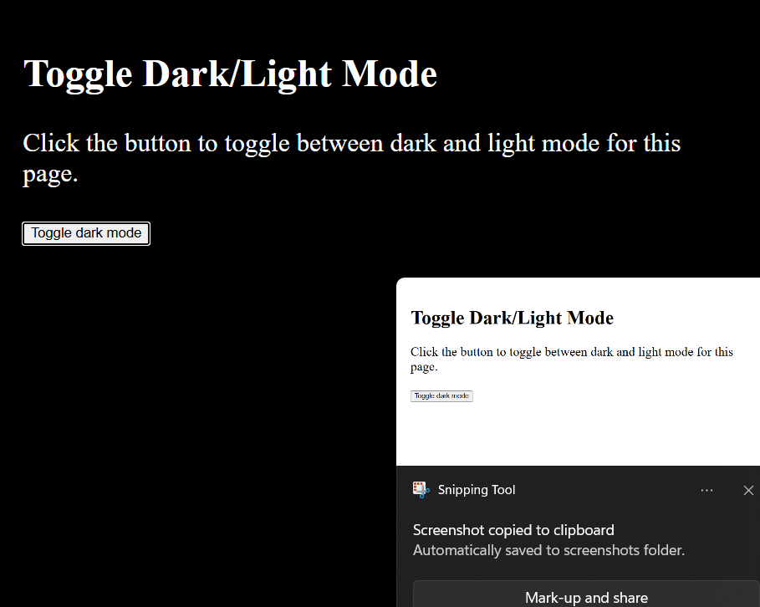

**SCREENSHOTS DURING CLASS**

**Cascading style sheet code in class with a incredible output of various grid**

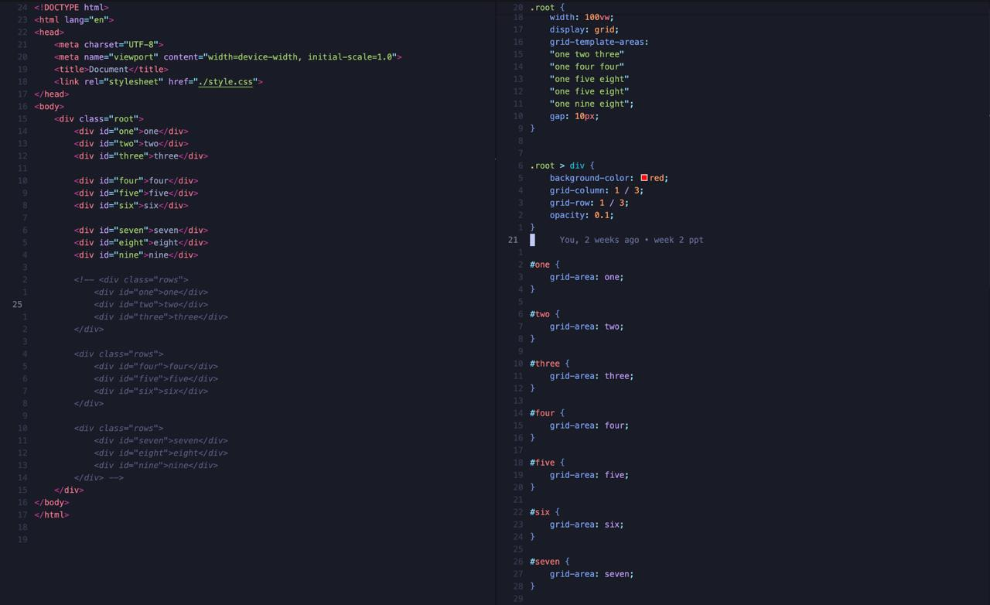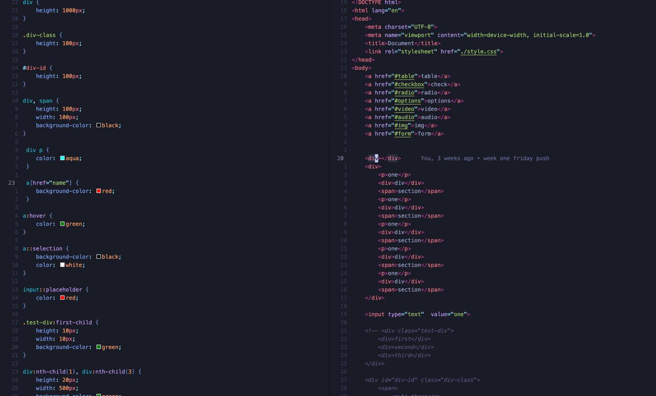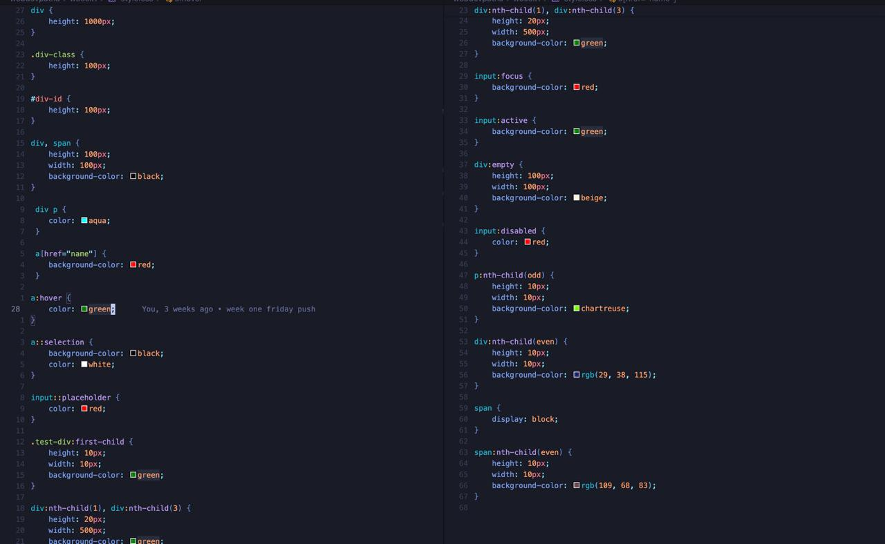

**OUTPUT :**

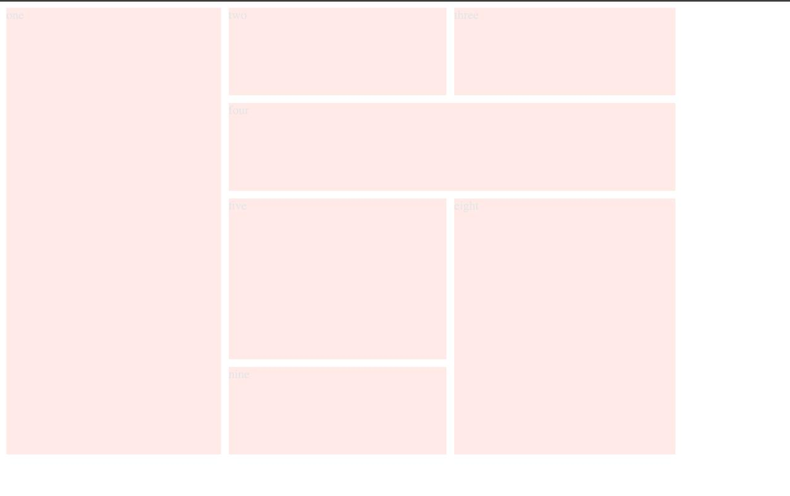

**Creating a HTMl form cod is given below with a incredible output bg – Green**

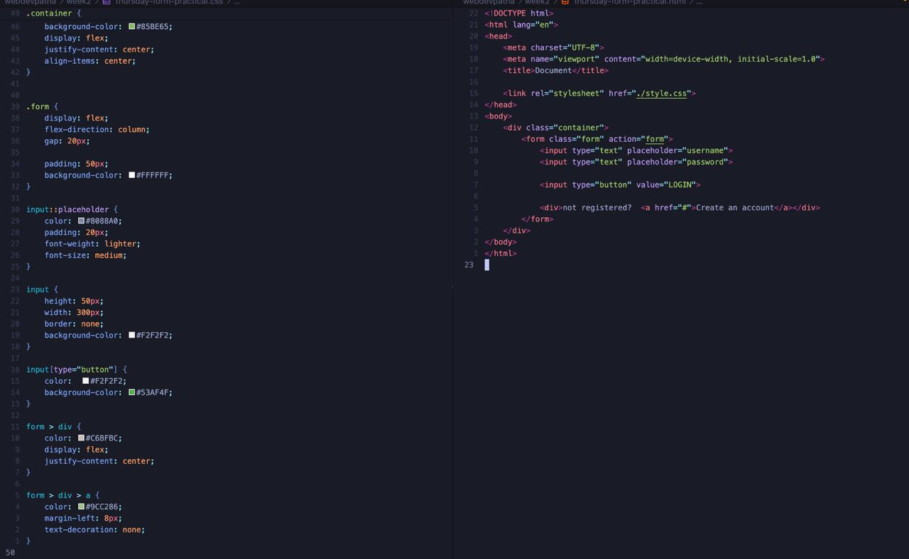

**OUTPUT :**

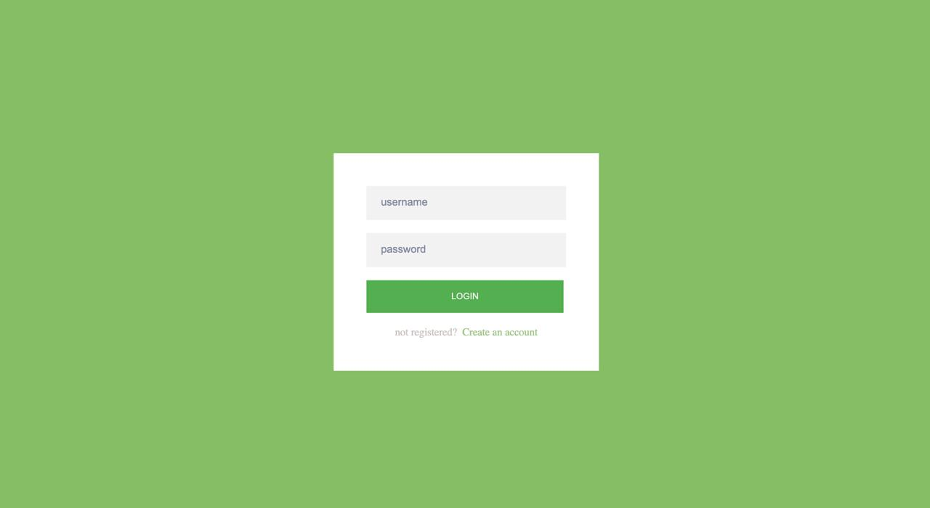

**And now we have a website which mainly works on JAVA SCRIPT , Here’s a code which changes background color in red or blue while clicking on red or blue with event handlers.**

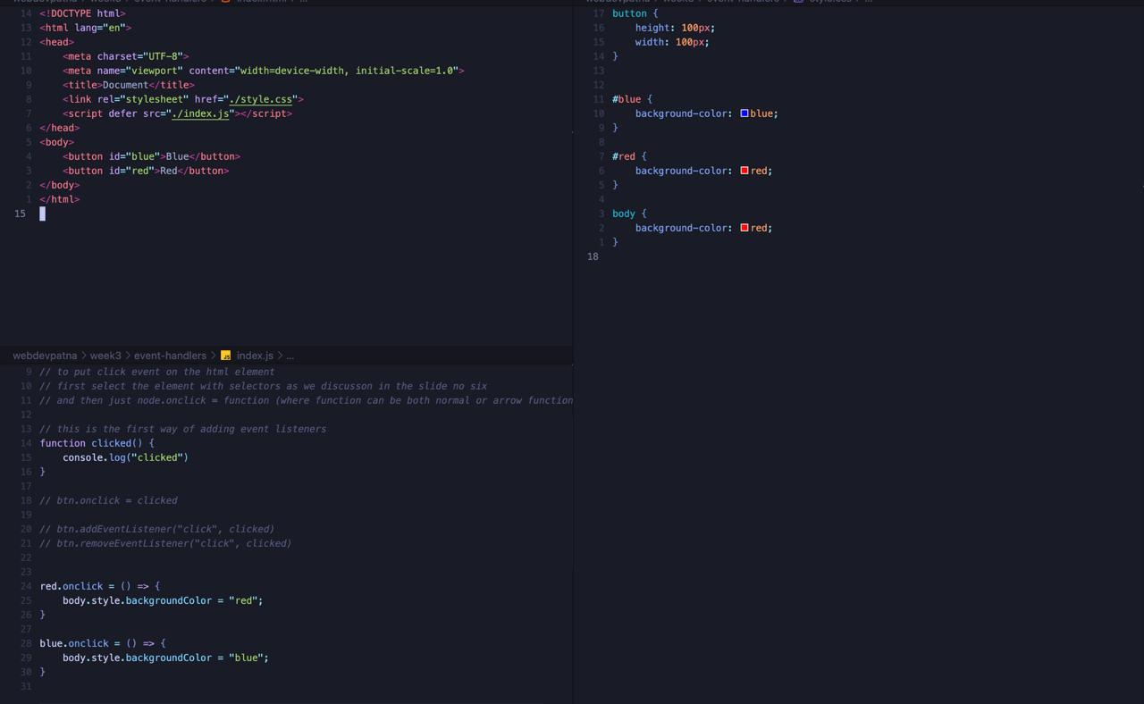

**OUTPUT :**



**CHALLENGES FACED & SOLUTIONS**

Web development is exciting, but it comes with its fair share of hurdles. Here’s a breakdown of **common challenges** developers face—and smart ways to tackle them,

### **⚠️ Top Challenges in Web Development & Their Solutions**

|  |  |
| --- | --- |
| **Challenge** | **Solution** |
| **1. Browser & Platform Compatibility** | Use cross-browser testing tools (like BrowserStack) and responsive design frameworks (like Bootstrap). |
| **2. Security Vulnerabilities** | Implement HTTPS, sanitize user inputs, and use authentication libraries. |
| **3. Performance Optimization** | Minify CSS/JS, compress images, and use lazy loading for faster load times. |
| **4. Choosing the Right Tech Stack** | Evaluate project needs and scalability before selecting tools and frameworks. |
| **5. Understanding Client Requirements** | Use wireframes, prototypes, and regular feedback loops to clarify expectations. |
| **6. UI/UX Design Consistency** | Follow design systems and conduct usability testing to ensure a smooth experience. |
| **7. Scalability & Maintenance** | Write modular code, use version control (like Git), and document everything. |
| **8. Integration with APIs or Services** | Use well-documented APIs and handle errors gracefully with fallback mechanisms. |
| **9. Keeping Up with Rapid Tech Changes** | Dedicate time for learning, follow dev blogs, and join communities like Stack Overflow. |
| **10. Time & Project Management** | Use Agile methods, task boards (like Trello), and set realistic milestones. |

**CONCLUSION & RECOMMENDATIONS**

Here’s a thoughtful **conclusion and set of recommendations** to wrap up your web development journey so far, Prince:

### **🧾 Conclusion**

Web development is a dynamic and evolving field that blends creativity with logic. From structuring content with HTML, styling with CSS, and adding interactivity through JavaScript, to managing user experience and backend logic—each layer plays a vital role in building modern, responsive, and user-friendly websites. As you've explored DOM manipulation, event handling, and even full stack concepts, you're already on a promising path toward becoming a well-rounded developer.

### **✅ Recommendations for Continued Growth**

|  |  |
| --- | --- |
| **Area** | **Recommendation** |
| **Practice & Projects** | Build real-world projects like a portfolio, blog, or weather app to apply concepts. |
| **Version Control** | Learn Git and GitHub to manage code and collaborate effectively. |
| **Frameworks & Libraries** | Explore React.js for frontend and Node.js or Express for backend development. |
| **Responsive Design** | Master Flexbox, Grid, and media queries to ensure mobile-friendly layouts. |
| **APIs & Data Handling** | Practice fetching data from APIs and working with JSON. |
| **Debugging & Testing** | Use DevTools, console logs, and testing libraries like Jest to catch bugs early. |
| **Stay Updated** | Follow dev blogs, YouTube channels, and communities like Stack Overflow or Dev.to. |
| **Soft Skills** | Improve communication, time management, and documentation habits. |

**REFERENCES**

List books, journals, websites, and other sources referred to in your report (if any).

If you're looking for reliable references to deepen your web development knowledge, here are some top-tier resources:

1. [**W3Schools References**](https://www.w3schools.com/references/index.php) – A comprehensive collection of documentation for HTML, CSS, JavaScript, SQL, Python, and more. Great for quick syntax checks and examples.
2. [**MDN Web Docs – Learn Web Development**](https://developer.mozilla.org/en-US/docs/Learn_web_development) – Created by Mozilla, this is one of the most trusted and detailed resources for learning frontend development. It covers everything from beginner to advanced topics with interactive examples.
3. [**GeeksforGeeks – Web Development**](https://www.geeksforgeeks.org/web-development/) – Offers tutorials, project ideas, and explanations of both frontend and backend technologies. Ideal for structured learning and interview prep.

These references are perfect for bookmarking as you continue building projects and expanding your skills.

**APPENDICES**

In the context of web development, **appendices** are optional sections typically added at the end of a report, documentation, or project portfolio. They provide **supplementary information** that supports the main content but would clutter the flow if included directly.

Here’s how you might structure appendices for a web development project:

### **📎 Common Types of Appendices in Web Development**

|  |  |
| --- | --- |
| **Appendix Type** | **What It Might Include** |
| **Code Appendix** | Full source code files or snippets too long for the main body |
| **Design Appendix** | Wireframes, mockups, or screenshots of UI/UX elements |
| **Data Appendix** | Sample JSON data, API responses, or database schemas |
| **Testing Appendix** | Test cases, bug reports, or performance benchmarks |
| **Documentation Appendix** | Setup instructions, environment configurations, or deployment steps |
| **Research Appendix** | Notes on frameworks/libraries evaluated, or user feedback from testing |

**THANKING YOU FOR JOINING WITH US**

**…………..LEKHNATH PRAJAULI**